**Assignment Hive 6.3:**

Explain Hive Architecture in Brief.

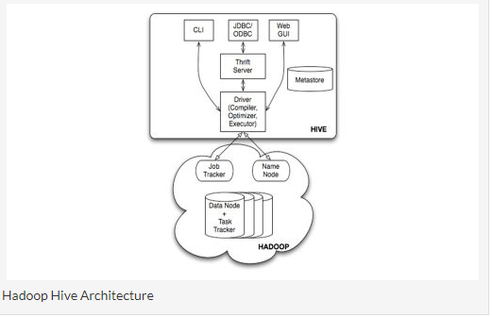

Primarily The diagram represents CLI (Command Line Interface),JDBC/ODBC and Web GUI (Web Graphical User Interface ).This represents when user comes with CLI(Hive Terminal) it directly connected to Hive Drivers,When User comes with JDBC/ODBC(JDBC Program) at that time by using API(Thrift Server) it connected to Hive driver and when the user comes with Web GUI(Ambari server) it directly connected to Hive Driver.

The hive driver receives the tasks(Queries) from user and send to Hadoop architecture.The Hadoop architecture uses name node,data node,job tracker and task tracker for receiving and dividing the work what Hive sends to Hadoop (**[Mapreduce Architecture](http://www.hadooptpoint.com/hadoop-mapreduce/" \t "_blank)**) .

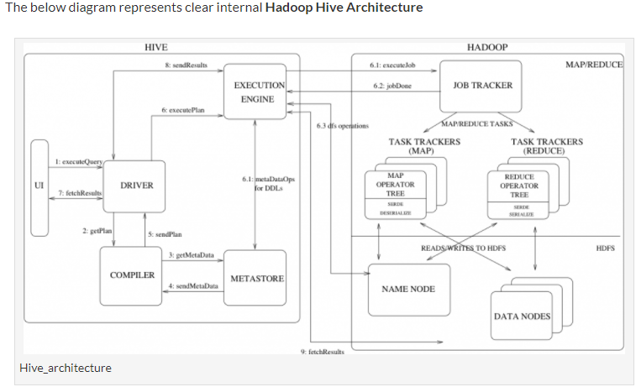

Queries are parsed and executed on Hadoop. The metastore is an important component that helps to determine how queries will be run.

Hive will store your data under the /user/hive/warehouse directory. Hive can automatically add compression and special directory structures (such as partitions ) to those data to improve query performance.

Hive stores metadata in a standard relational database. Out-of-the-box Hive comes with an open source, lightweight, embedded SQL database called Derby, which is installed and run on the client machine along with Hive.

**Explain Hive Components in Brief.**

Major Components of Hive

UI :- UI means User Interface, The user interface for users to submit queries and other operations to the system.

Driver :- The Driver is used for receives the quires from UI .This component implements the notion of session handles and provides execute and fetch APIs modeled on JDBC/ODBC interfaces.

Compiler :- The component that parses the query, does semantic analysis on the different query blocks and query expressions and eventually generates an execution plan with the help of the table and partition metadata looked up from the metastore.

MetaStore :- The component that stores all the structure information of the various tables and partitions in the warehouse including column and column type information, the serializers and deserializers necessary to read and write data and the corresponding HDFS files where the data is stored.